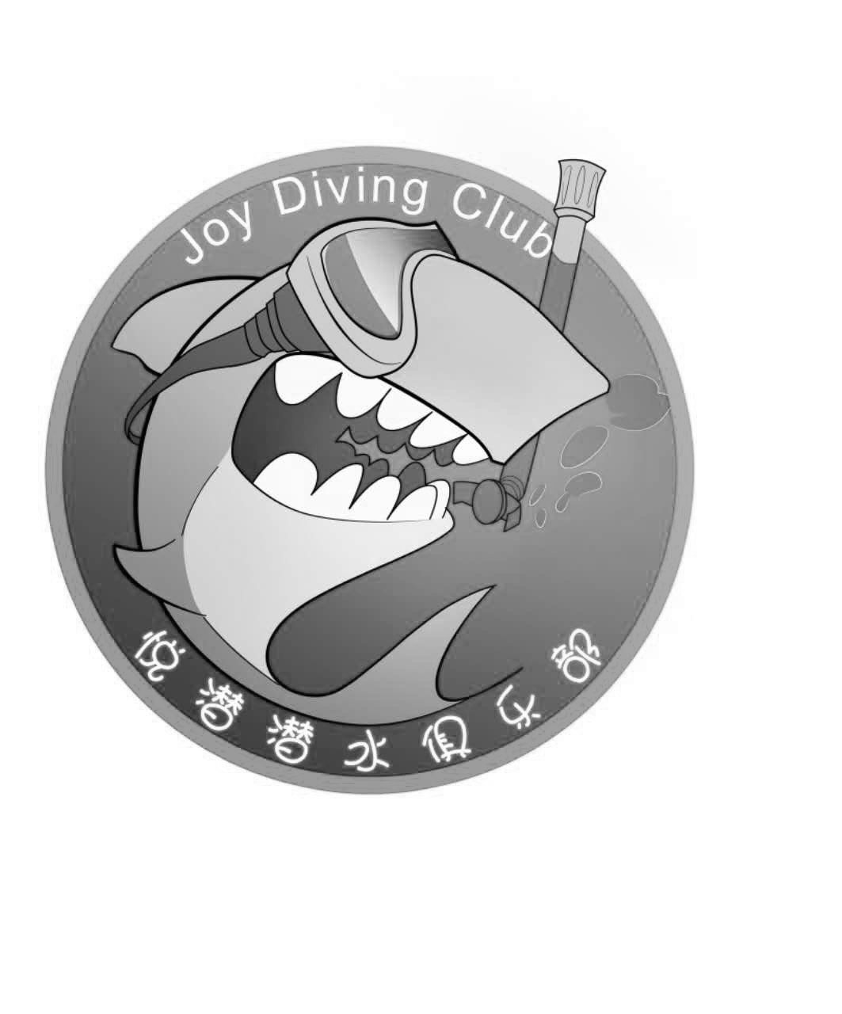

1 May 2018
Dear Mr. Sergi Perez Garcia,
As organizer of “Cave Dive Conference of Guangxi Liuzhou”, we would like to welcome Mr. Sergi Perez Garcia to participate our conference on 20-27 Oct 2017, as conference VIP.
Full name: Mr. Sergi Perez Garcia
Passport no: 8888888
Date of Brith: DD MMM YYYY
Thank you and looking forward to the pleasure of seeing you soon.
For more information, please don't hesitate to contact us for any enquiries:
Campany Name: Yue Qian Sport Management Co., LTD
Address: No.7 Gui-Chung Road,Chengzhong District, Liuzhou City,Guangxi State, China

Tel: +86-772-881-5181
Contact Person: XIE YAN

